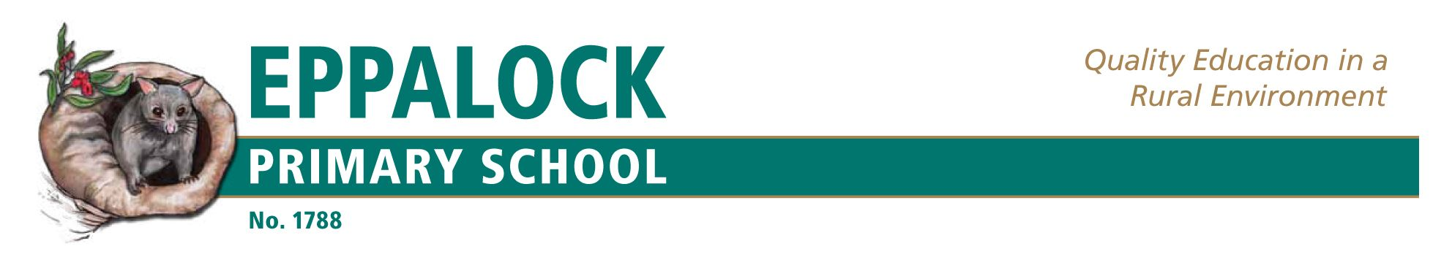
Enrolment Policy
As a school within the Victorian public school sector, Eppalock Primary School will comply with all government and department enrolment requirements.
Eppalock Primary School will be a school without a zone but with a neighbourhood and will consider
all students who make inquiries from its neighbourhood
All students and a family member or a caregiver will be interviewed by the Principal prior to enrolment to ascertain the appropriate year level and learning program.
Principal will contact previous schools of all students seeking transfers to discuss the circumstances of the transfer, to seek a transfer note or an immunisation certificate (if enrolling), and to discuss any academic or behavioural matters. The principal has the authority to defer admission in order that enquiries of the previous school are carried out in the interests of the student.
The enrolment policy of the school will take account of all requirements of laws relating to discrimination, equal opportunity, privacy and immunisation.
Enrolment form must be accompanied by:
- Birth certificate
- Immunisation status certificate
- Visa information (where applicable)
- Relevant legal documents (where applicable)
- All enrolments will require the completion of the Dept of Education ‘Confidential Student Information Enrolment Form’, with details entered immediately on CASES21.
Eppalock Primary School is an inclusive school and it will provide programs for all enrolees. The learning program will cater for students who have special learning needs.
An enrolment register will be maintained.
The enrolment register will be kept up to date by a member of the school office staff. Changes to the register will be done regularly to reflect current student numbers and movement of students into and out of the school. Student destinations will be tracked.
International students will be enrolled in a manner consistent with the guidelines for enrolment of international students of the Department of Education and Early Childhood Development

Evaluation
This policy will be reviewed annually or more often as necessary due to changes in regulations or circumstances.
Last Review : August 2017

